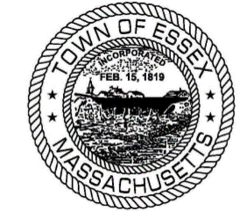

ESSEX BICENTENNIAL CELEBRATIONS 2019

February 15 Ice Cream Social
- Essex Elementary School, 6-8 pm
April 27 Progressive Dinner
- Reservations limit 200 guests, 5 pm
June 22 Madam Varney Tea
- First Congregational Church, 11-3 pm
July 20 Rededication of Ancient Cemetery
- Ancient Cemetery, Main Street, 1 pm
August 9 Fireworks
- Over the Marsh @ Sunset
- Creative Parking
August 9 Food Trucks
- 5-8 pm Memorial Park
August 10 Bicentennial Parade
- Main Street
- Step off 10 am
Old Timers baseball game
- After the Parade
August 11 Reception for Citizens Age 80 and Up
- Town Hall 3rd floor, 1-4 pm
September 7 Old Essex Day
- Centennial Grove 11-3pm
October 5 Graveyard Tours
- Ancient Cemetery, Noon-5 pm
December 22 Winter Solstice Celebration
- Town Hall 3rd floor, 1-4 pm
_______________________________________________________________

ONGOING EVENTS - Town Hall, 3rd Floor
Historical Biographies and Stories Monthly Displays

